**ANALYSING HOUSING PRICES IN METROPOLITAN AREAS OF INDIA**

1. **INTRODUCTION**:

**Analyzing housing prices in India's metropolitan areas is a crucial endeavor in the realm of real estate and urban economics. These bustling cities represent complex and dynamic real estate markets, influenced by various socio-economic, environmental, and policy factors. Understanding housing price trends provides essential insights for prospective buyers, investors, and policymakers. It sheds light on affordability, market dynamics, and the overall economic health of these urban hubs. Thus, examining housing prices is fundamental to making informed decisions and shaping the future of these metropolitan areas.**

**PURPOSE:**

* **Investment Decision: It assists investors in identifying profitable real estate opportunities.**
* **Affordability Assessment: It helps potential homebuyers determine their ability to enter the housing market.**
* **Policy Formulation: Policymakers use this data to create housing and urban development policies.**
* **Economic Indicator: Housing prices are a barometer for the overall economic health of a region.**
* **Quality of Life: It influences the well-being and quality of life for residents in these bustling metropolitan areas.**

1. **PROBLEM DEFINITION AND DESIGN THINKING:**

**EMPATHY MAP:**

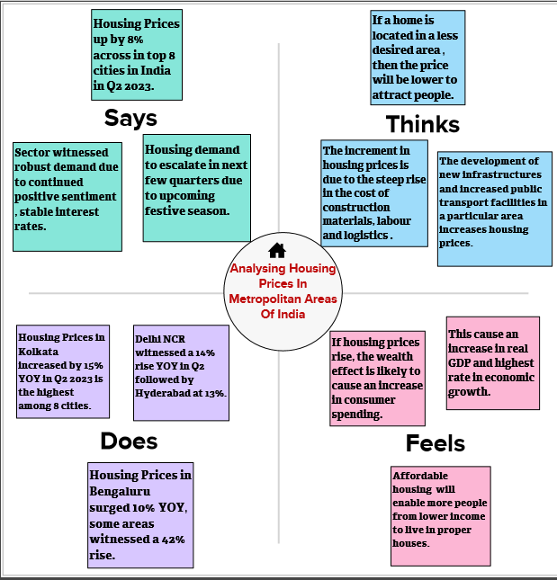

**IDEATION AND BRAINSTORMING MAP:**

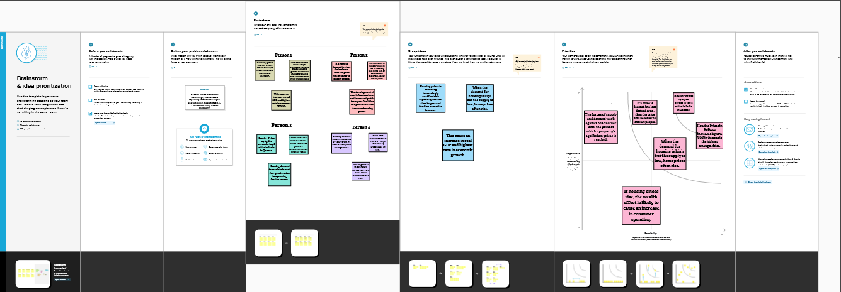

1. **RESULT:**

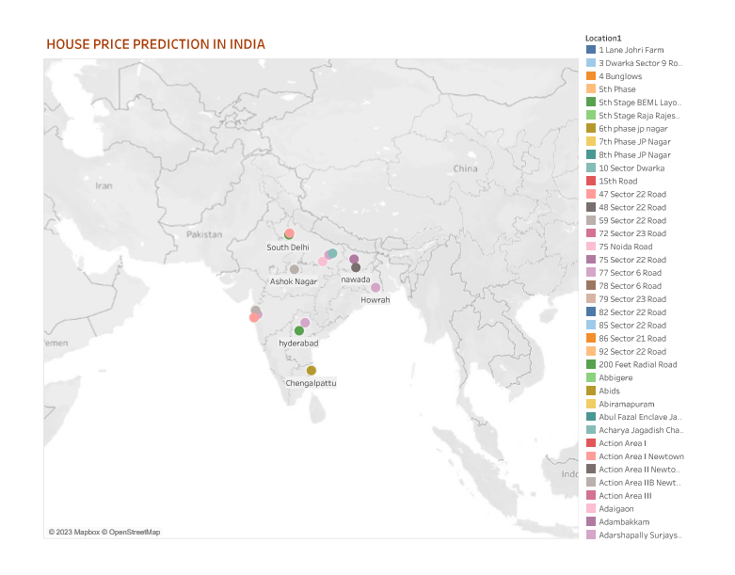

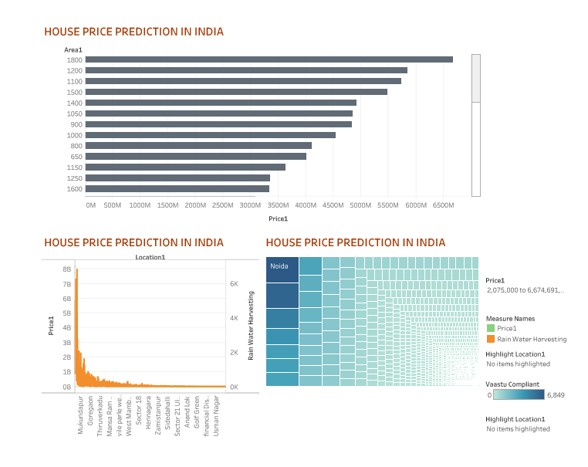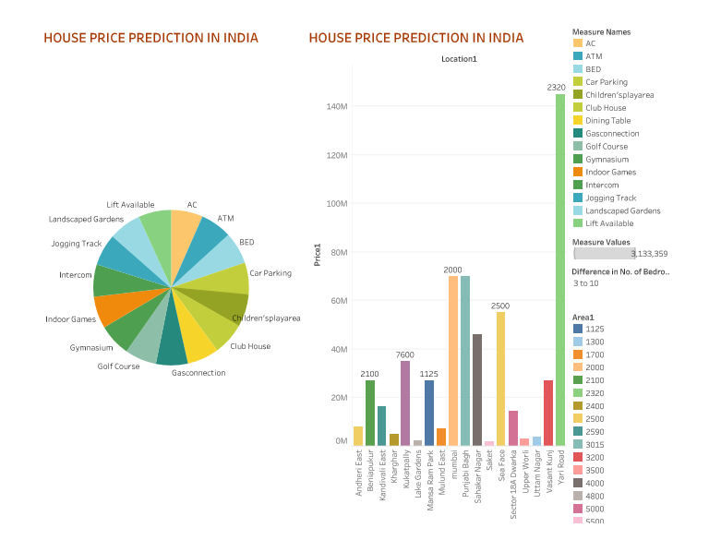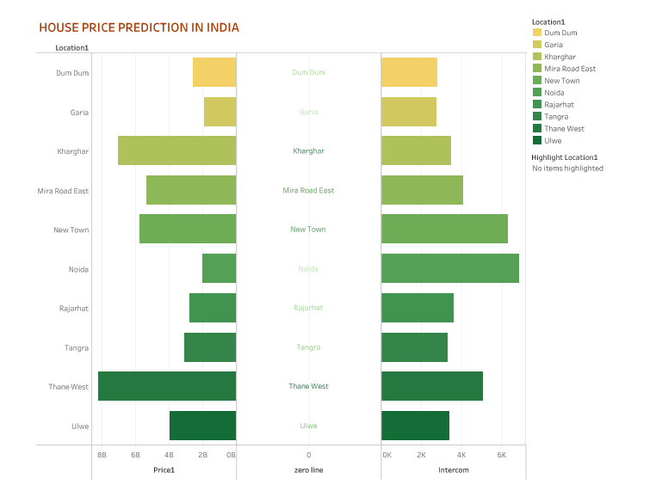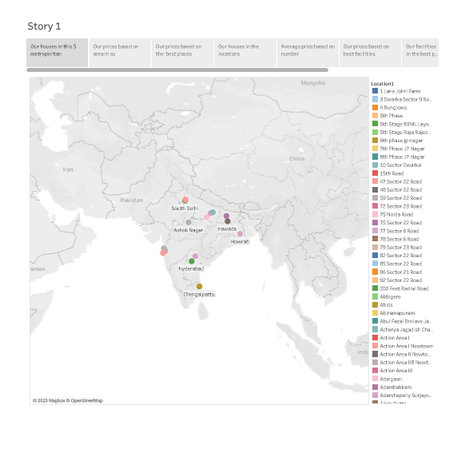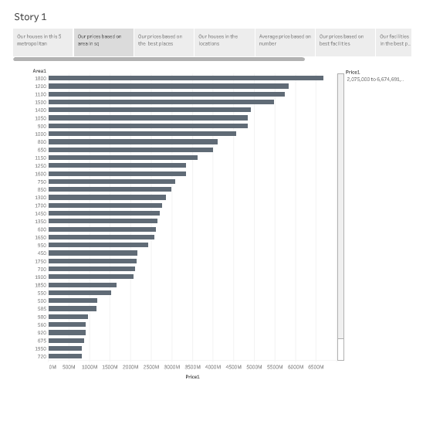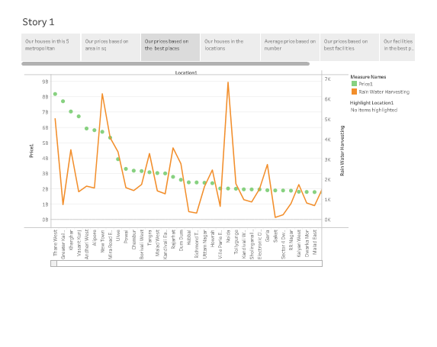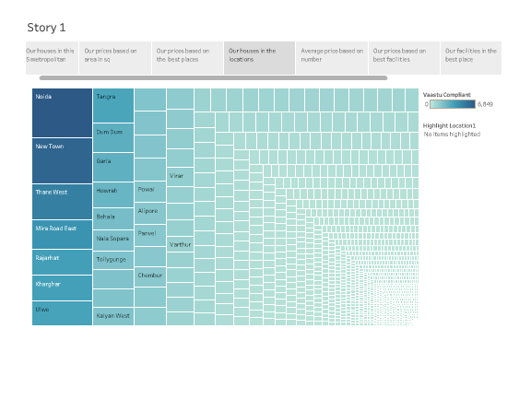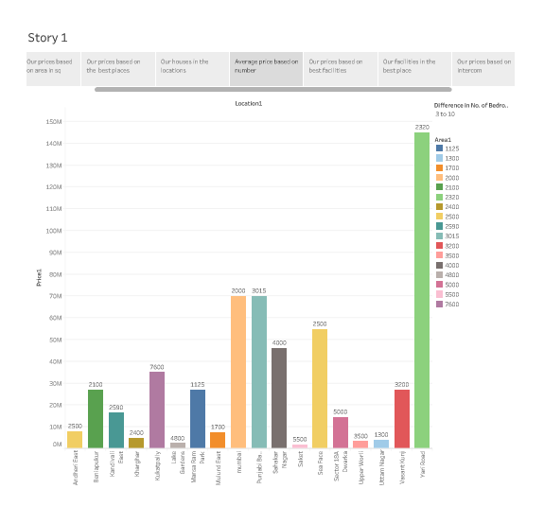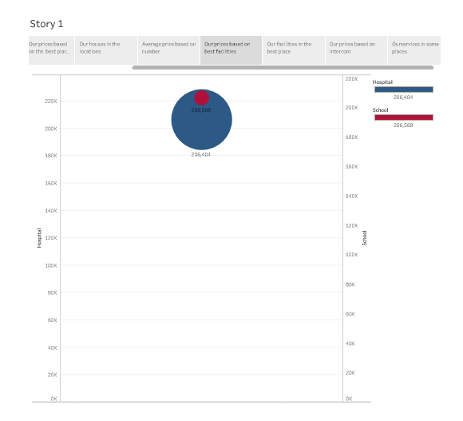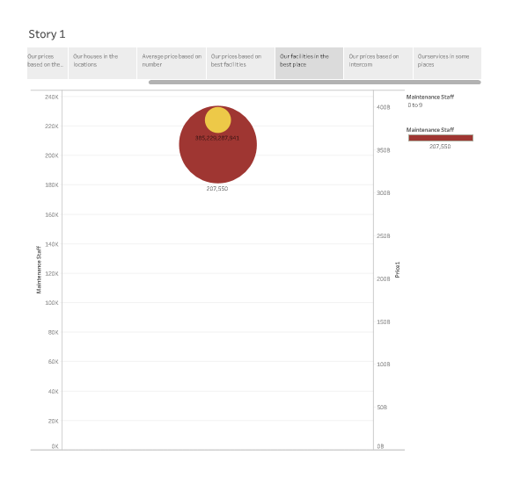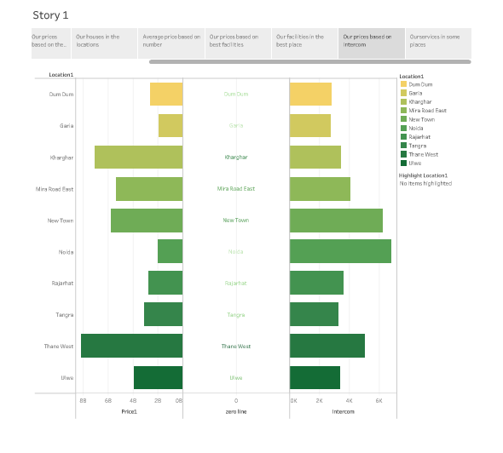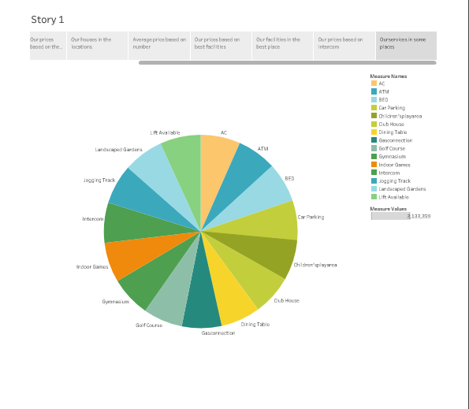

1. **ADVANTAGES:**

* **Investment Insights: Analyzing housing prices offers valuable insights for real estate investors to make informed decisions and maximize returns.**
* **Financial Planning: It aids prospective buyers in assessing affordability and planning their financial future based on property values.**
* **Market Trends: Understanding housing price trends helps both buyers and sellers anticipate market shifts and make timely decisions.**
* **Policy Development: Policymakers rely on this analysis to formulate effective housing and urban development policies that cater to the needs of the population.**
* **Economic Health: Housing prices serve as a critical economic indicator, reflecting the overall financial stability and growth potential of metropolitan areas in India.**

**DISADVANTAGES:**

* **Volatility Misinterpretation: Overreliance on housing price analysis can lead to misinterpretation of market volatility, potentially leading to poor financial decisions.**
* **Inaccurate Data: The data may sometimes be incomplete, inaccurate, or outdated, making it difficult to rely solely on it for decision-making.**
* **Speculative Behaviour: Excessive focus on prices can encourage speculative behaviour, leading to market bubbles and crashes.**
* **Socio-economic Bias: It may inadvertently exacerbate socio-economic disparities, as those already invested in the market may benefit more.**
* **Market Manipulation: Manipulative practices by developers, agents, or investors can distort prices, leading to unreliable analysis**.

1. **APPLICATIONS:**

* **Real Estate Investment: Investors use housing price analysis to identify promising investment opportunities in growing metropolitan areas.**
* **Home Purchase Decisions: Prospective buyers rely on this data to assess affordability and make informed decisions about property purchases.**
* **Urban Planning: City authorities and planners utilize the analysis to make informed decisions about infrastructure development, zoning regulations, and land use policies.**
* **Economic Indicator: Housing price trends offer insights into the overall economic health and growth potential of a region, aiding economic planning.**
* **Socio-economic Research: Researchers employ housing price analysis to understand socio-economic disparities and their impact on communities, informing policy and interventions.**

1. **CONCLUSION:**

**Analyzing housing prices in India's metropolitan areas is a pivotal endeavor with significant implications for various stakeholders. It provides invaluable insights for investors, homebuyers, policymakers, and urban planners, enabling informed decision-making. The dynamic nature of these markets calls for continual analysis to address affordability challenges, foster sustainable development, and ensure equitable resource allocation. Accurate housing price analysis serves not only as an economic barometer but also as a catalyst for shaping the quality of life and prosperity of India's urban population.**

1. **FUTURE SCOPE:**

**The future scope of analyzing housing prices in Indian metropolitan areas holds promising opportunities:**

* **Technology Integration: Enhanced data analytics and AI will provide more accurate and real-time insights, aiding in timely decision-making.**
* **Affordability Solutions: Innovations in housing finance and policy are likely to address the pressing issue of housing affordability.**
* **Sustainable Urbanization: Housing price analysis will focus on aligning with environmental sustainability goals, promoting eco-friendly development.**
* **Smart City Development: It will play a central role in planning and developing smart cities, offering more efficient and connected living spaces.**
* **Real-time Market Insights: Advanced analysis methods will offer real-time market insights, aiding both buyers and investors in navigating dynamic urban real estate markets effectively.**